- Deploy Your flask backend and express frontend in amazon single ec2 instance.
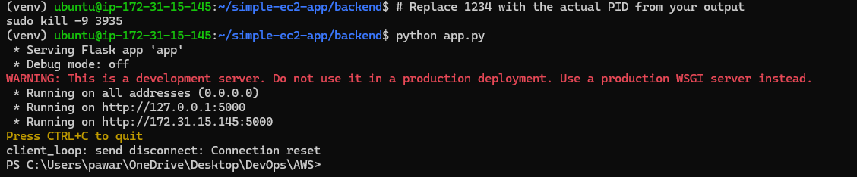
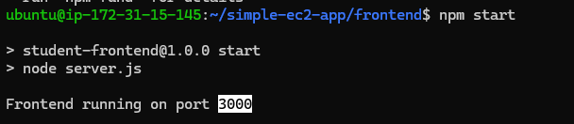
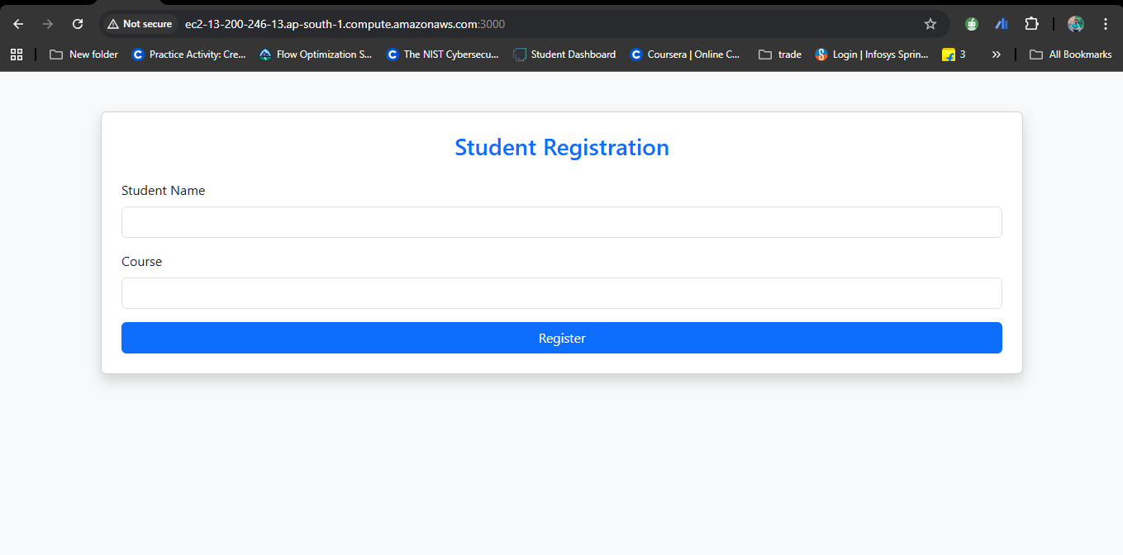
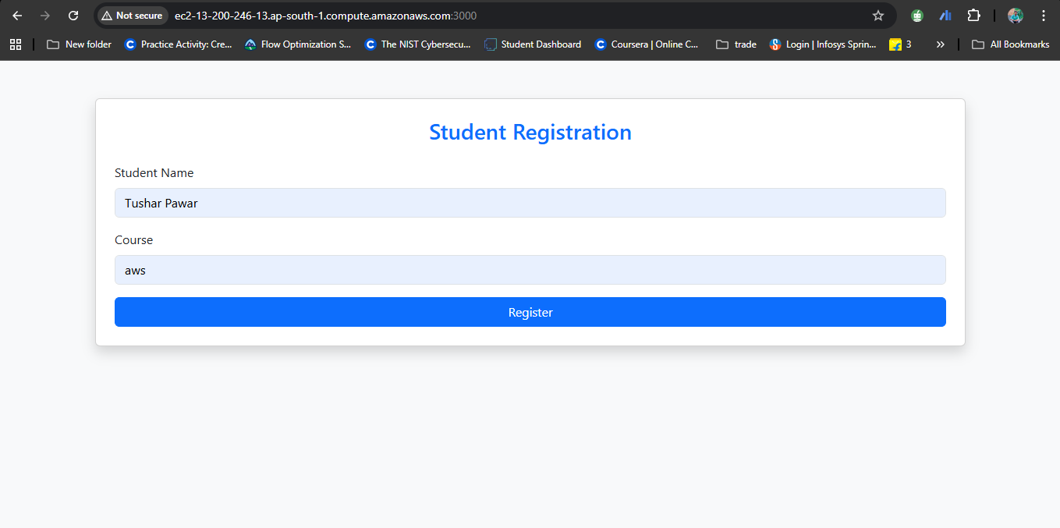
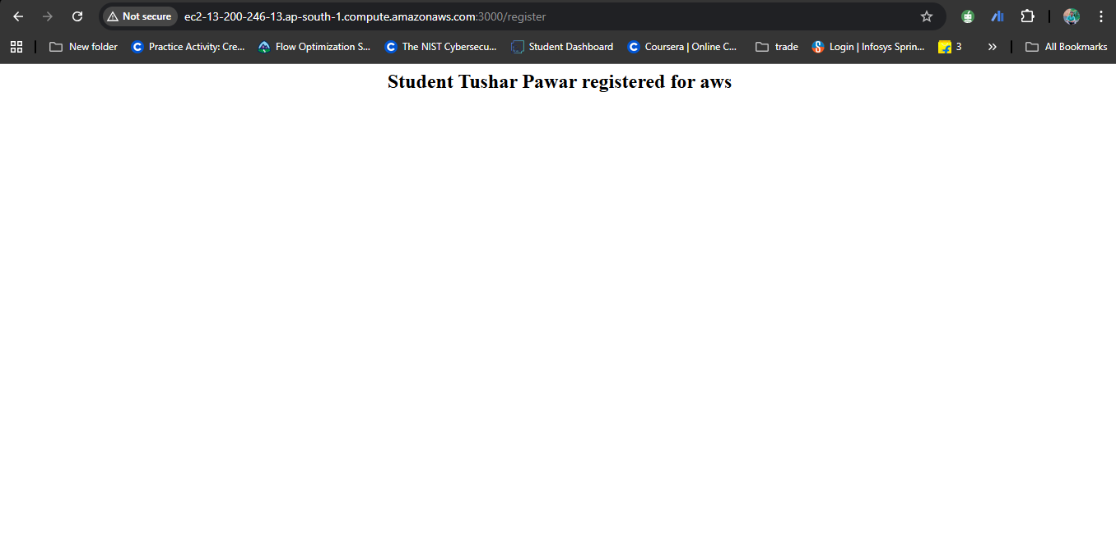

- Deploy Your flask backend and express frontend in separate ec2 instances.
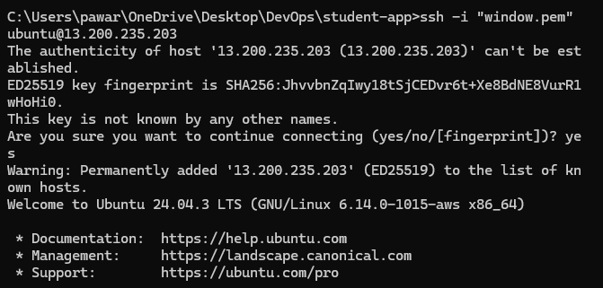
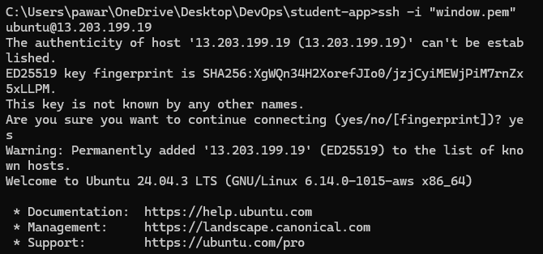

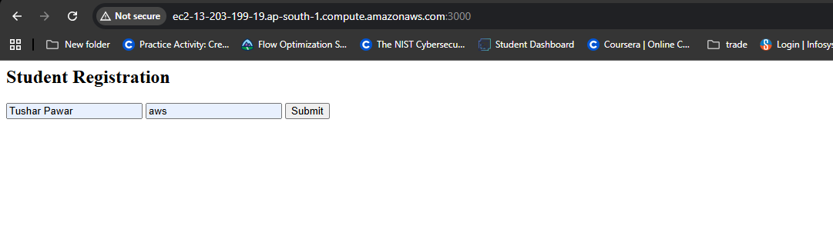

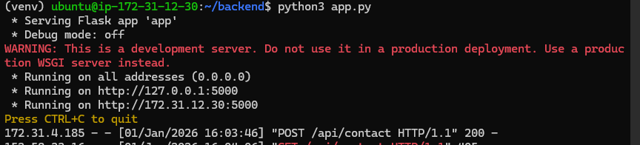
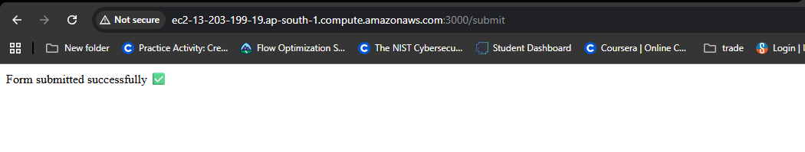

- Deploy Your flask backend and express frontend Docker Container using aws ecr, ecs and vpc services
🧪 Building Flask backend Docker image locally
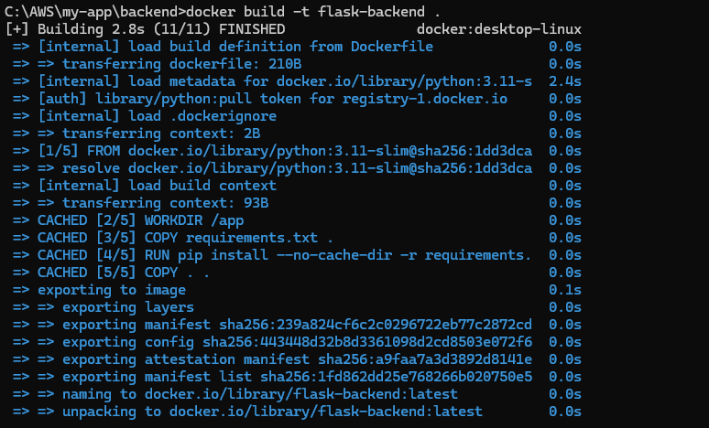
🎨 Building Express frontend Docker image locally
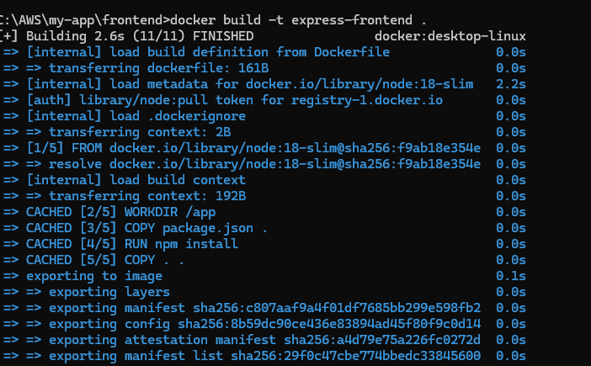

🏗️ Creating ECR repository for Flask backend in Mumbai region
🏗️ Creating ECR repository for Express frontend in Mumbai region
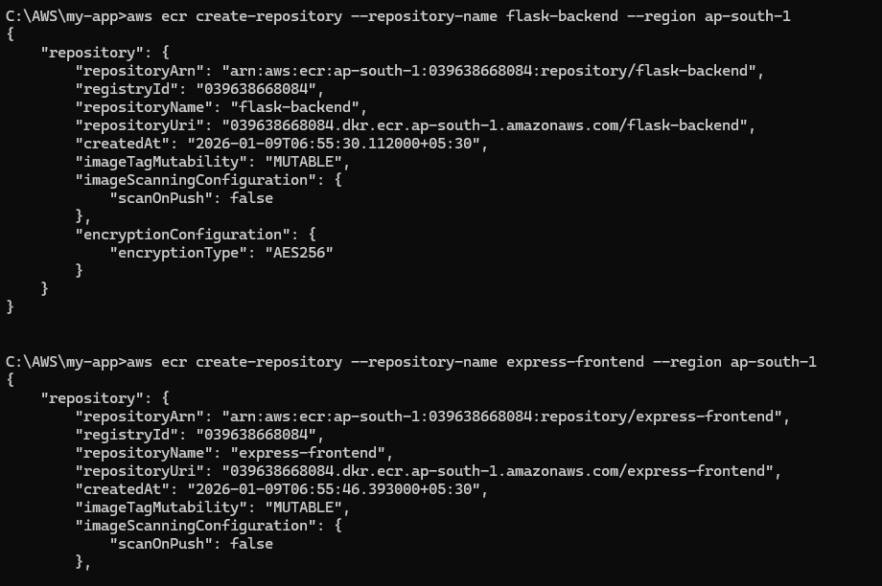

📤 Tagging backend Docker image for ECR repository
🚀 Pushing Flask backend image to AWS ECR - Upload complete!
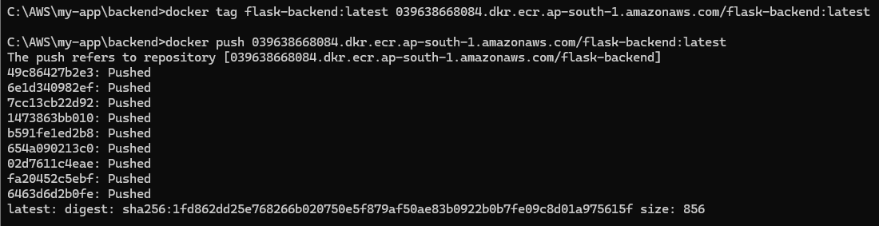
📤 Tagging frontend Docker image for ECR repository
🚀 Pushing Express frontend image to AWS ECR - Upload complete!
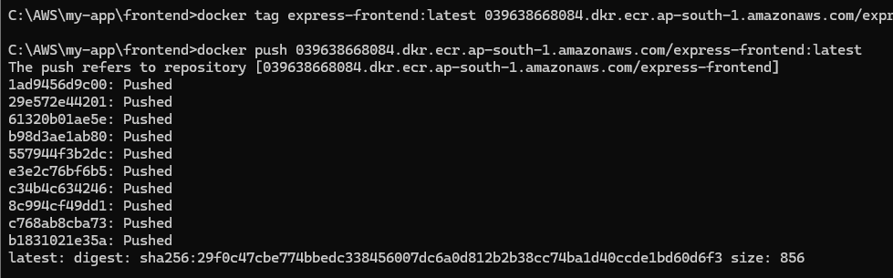

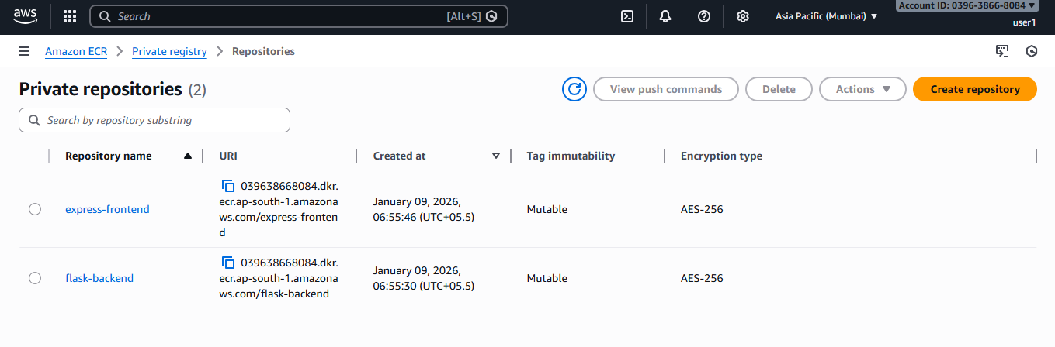

🌐 Creating VPC with CIDR 10.0.0.0/16 for our application network
📍 Creating public subnet 1 in ap-south-1a availability zone
📍 Creating public subnet 2 in ap-south-1b availability zone
🌍 Creating Internet Gateway to enable internet access for containers
🔗 Attaching Internet Gateway to VPC
🔌 Associating both public subnets with the route table
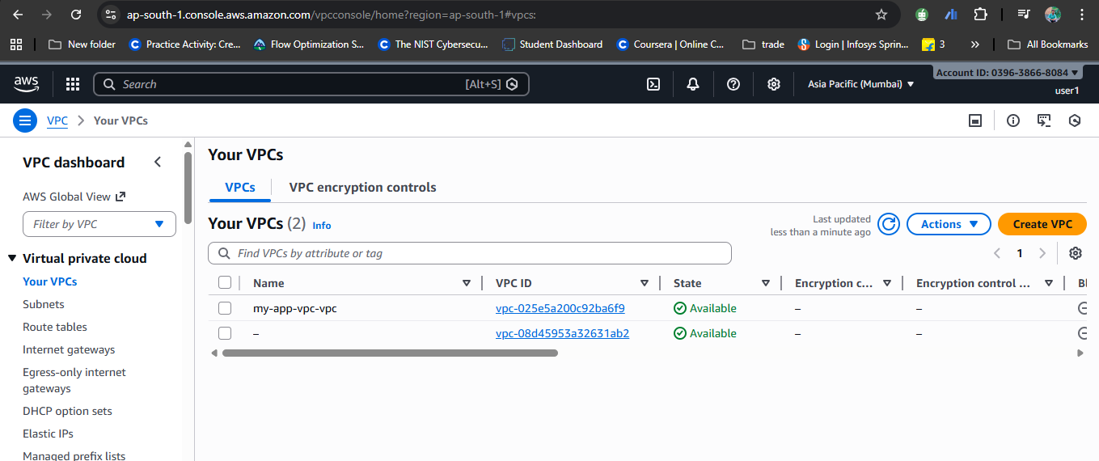
🛡️ Creating security group for backend - allowing port 5000
🛡️ Creating security group for frontend - allowing ports 80 and 3000
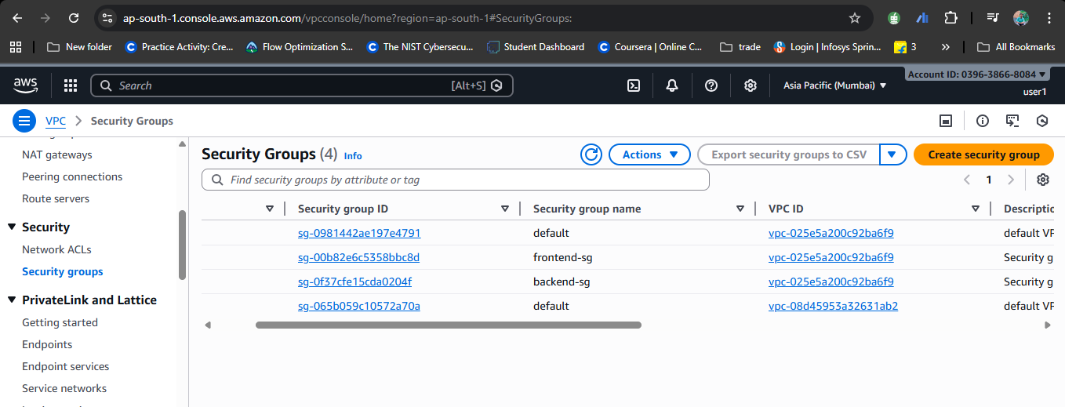
⚙️ Creating ECS Cluster with AWS Fargate (serverless containers)

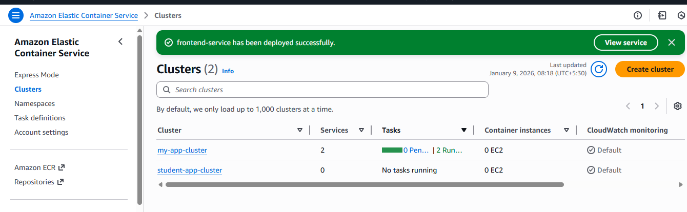

📋 Creating ECS Task Definition for Flask backend
📋 Creating ECS Task Definition for Express frontend
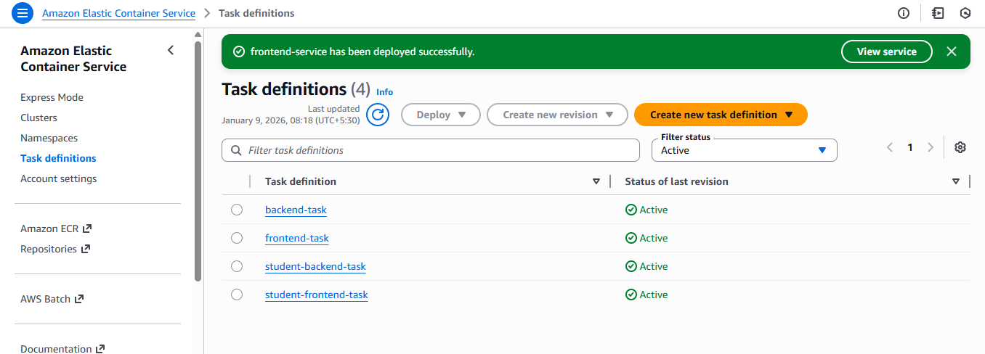
🚢 Creating ECS Service for frontend with 1 desired task
📡 Configuring frontend networking with public IP enabled
✅ Backend service deployed - waiting for task to start running...
✅ Frontend service deployed - waiting for task to start running...

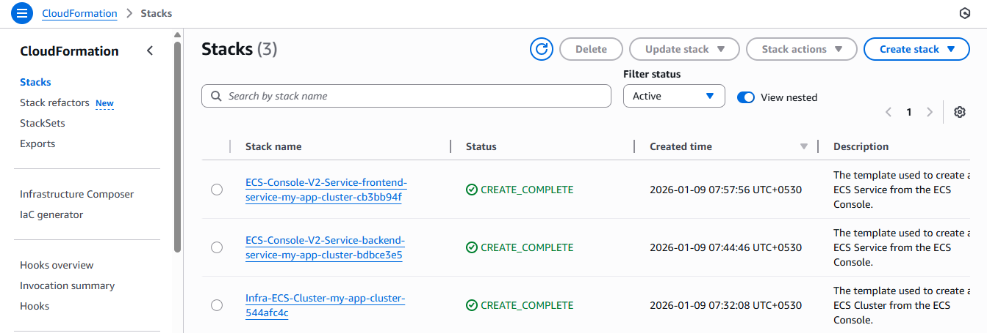

🌐 Accessing frontend application via public IP on port 3000 and ✅ Application loaded! Beautiful gradient UI is working perfectly!
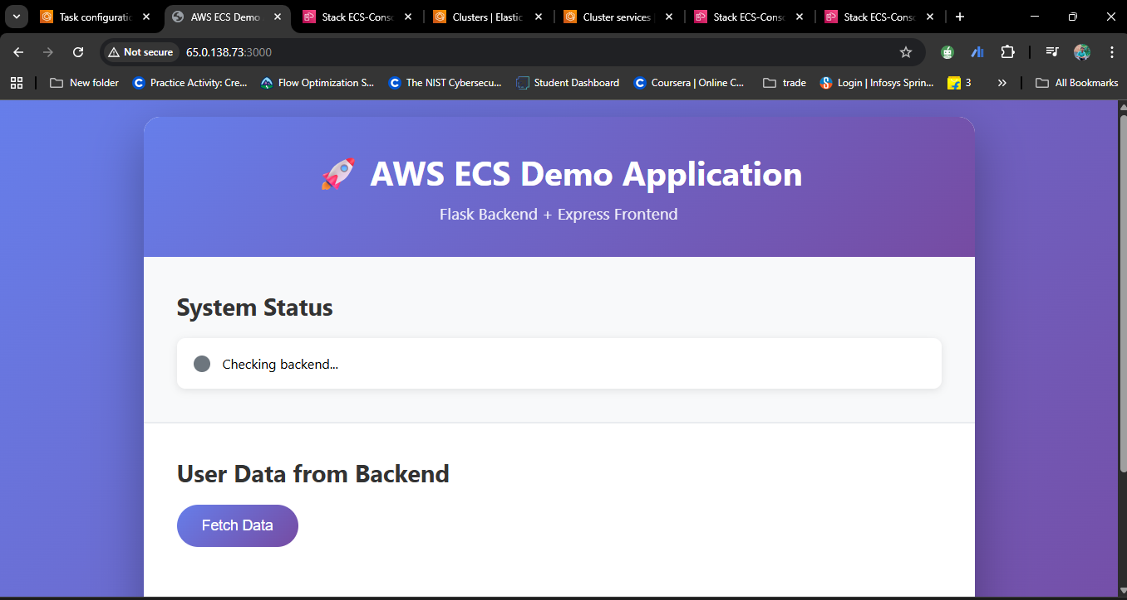

🔍 Checking backend health status - System shows "Online"
📊 Clicking "Fetch Data" button to retrieve user data from backend
🎯 Success! Backend API returned user data and displayed beautifully

